Ric Generator User Guide

# Overview

RicGenerator is a window form tool used for ETI content automation. It’s an execution file, no need to install, just to copy required assemblies to your local machine.

Major features by now:

* Tree-model task organization;
* Task scheduling;
* Task configuration;
* Task result viewer;
* Task status tracking

# Operation Guide

## Where to Get

Currently, all the release build versions are under \\L00028898.apac.ime.reuters.com\Shared\Build\, which are named according to the release date and the SVN version number, take the build “05_12_2011_V392” for an example, of whose name, “05_12_2011” is the release date and “V392” are the SVN version number.

You can get the latest version based on the directory name, that is ,the latest date and the biggest SVN version number.

## How to Use

Step1. Copy required assemblies into your local machine.

Step2. Run Ric Generator by clicking Ric.Generator.exe;

Step3. Select tasks by clicking the second check box column;

Step4. Do configuration for each task, Configuration Form

Step5. Schedule (Timer Form) and run task (User can check task status real time)Task View Form

Step6. After all tasks completed, see the result on Result View Form

**Note**: Before checking result, please go through the log file, whose name was composed by task name and time, like “ Log_HKFMAndBulkFileGenerator_2011-12-05_14-31-24_bd65fc13-bd61-46b2-82cb-331b4984eed0.log”

Details, please see 2.3~2.6.

## Task View Form

After running “Ric.Generator.exe”, the main form (Figure1: Task View Main Form) for this tool will pop up.

On the left panel, it shows the market set: HK, Korea and Thailand currently.

On the right panel, it lists the tasks. By default, it shows all the tasks under “ETI Automation”. User can also select a specified market and only tasks belong to this market will display on the right panel. User can select/ unselect a task by clicking the second checkbox column.

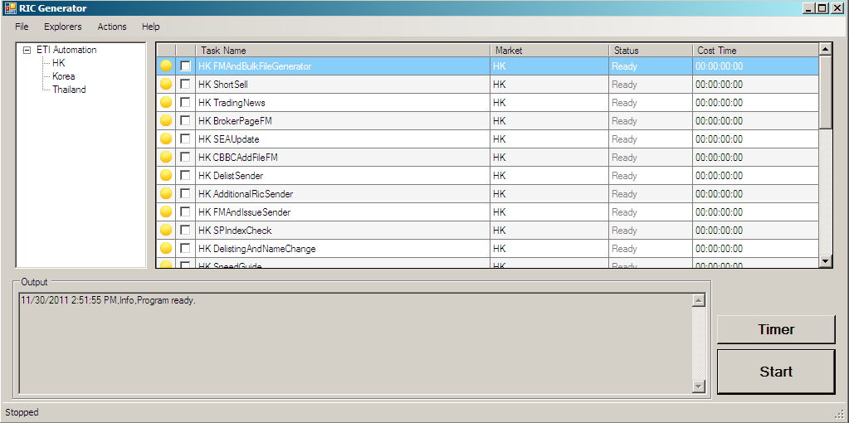

*Figure1: Task View Main Form*

For each task:

* Task Name: Distinguish each task, usually it was named according to the task requirements.
* Market: Indicate which market the task belongs to.
* Status: Indicate the status of the task, it has four statuses: Ready, Running, Completed and Failed. Accordingly, the first icon column can also indicate the task status. Status will be updated in real time during the running process.

|  |  |  |
| --- | --- | --- |
| Icon | Status | Description |
|  | Ready | The task is ready to be run |
|  | Running | The task is in the running process |
|  | Completed | The task has finished successfully getting the result successfully |
|  | Failed | The task has finished with some errors |

* Cost Time: Its value specifies how much time has cost for running this task. By default, the value is “00:00:00:00”

In the “**Output**” text box, some real time statistical data will be displayed: the start running time of each task, which task is running, and the error message if a task is failed.

“**Start**” button, click this button will start a new task running process. Users can select one or multiple tasks, after clicking “Start” button, the selected tasks will be executed serially one by one.

“**Timer**” button, click this button, a Timer form will pop up. In this form, user can schedule tasks. Details, please see the 2.2 Timer Form

## Timer Form

If click “Timer” button on “Task View Main Form (figure1)”, the Timer form( Figure2) will pop up. On this form, user can schedule tasks. There’re three parameters can be set:

* First Run Time: this parameter indicates when the selected tasks will start to run for the first time.
* Interval Time: This parameter indicates the interval time between each running time.
* Repeat Times: This parameter indicates how many times the selected tasks will be run.

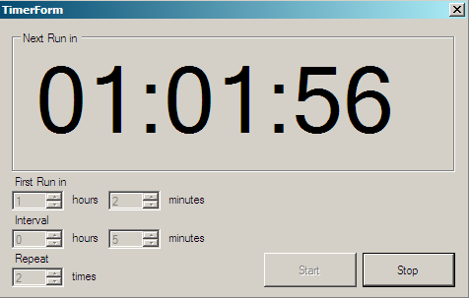

*Figure 2: Timer Form*

After setting this parameters, start countdown by clicking “Start” button. User can see how much time left for the next run. User can also stop the countdown by clicking “Stop” button.

## Configuration Form

Once select a task, double left-click, the configuration form (Figure3: Configuration Form) will pop up.

There’re two columns, of which the first one is the configuration field name, and the second one is the field value. Each task corresponds to a configuration file(.config), all the content will be displayed on the form. User can modify task configuration by editing on this form. The modification will be saved by clicking “OK” button, user can also drop the modification by clicking “Cancel” button.

User can also open the configuration window by right clicking and select “Open Config”.

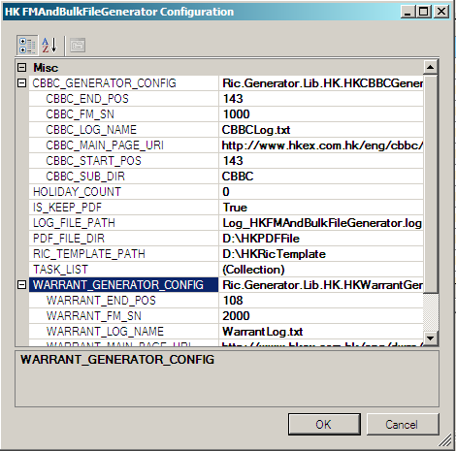

*Figure3: Configuration Form*

## Result View Form

After the execution finished, user can view the results on “Result View Form” (Figure4) by right clicking and selecting “Open Result”.

For each result for a task:

* Name: The result name which can be a file, directory and so on.
* Description: The description for this task which will give detailed description information.
* Path: The path value for the result, usually a file path, directory or Url.

User can specify a result and click, then the related file, webpage will be opened. User can check and modification.

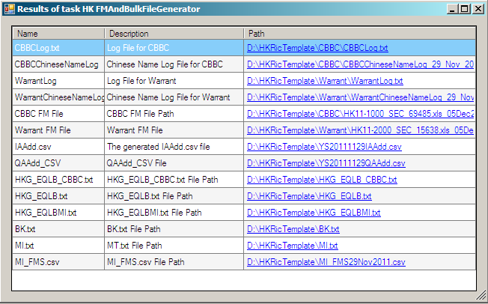

*Figure4: Result View Form*

# Contacts

Please feel free to contact [Meizhi.Hu@Thomsonreuters.com](mailto:Meizhi.Hu@Thomsonreuters.com) or <Yanxiang.Zhang@Thomsonreuters.com> for details if any problem.